##### 15SE201J-PROJECT REPORT

###### ***Submitted by****:*

*H. Gurubalan.*

***Register Number****:*

*RA1611003010099.*

***Batch****:*

*B1.*

*In partial fulfilment for the award of the degree*

*of*

*B.Tech.*

**In**

**Computer Science Engineering,**

**

*SRMUNIVERSITY*

*KATTANKULATHUR*

**Super Market Billing System**

Submitted by,

H. Gurubalan,

CSE,

RA1611003010099**Content**

|  |  |
| --- | --- |
| Title | Page number |
| Introduction | 4 |
| Architecture/Block Diagram | 4 |
| Implementation | 5 |
| Source Code | 6 |
| Screenshots | 20 |

**Introduction**

This is the C++ Project about Super Market Billing System. (SMBS). This is used in marketing systems and basically used to calculate the total bill a customer wants. It also includes discount percentages and also a unique product number for each product which the administrator can actually set and add/delete products from the product menu.

Hence this is a simple program to do that. This uses files and streams to store the data of the administrator (The products he is adding/creating) and hence is displayed out on the product menu to the customers.

We will now see the Block diagram/Architecture diagram for better understanding.

**Architecture/Block Diagram**

For this I have used UML diagrams to give an easy and precise explanation. The software used is StarUML and hence the exported diagram is given in next page.

The people, which are the Customers and the Administrator are actually given as actors and their functions are also given.

The numbers are actually the options and what we type in the program.

This will be understood better in the screen shots given later in this document.

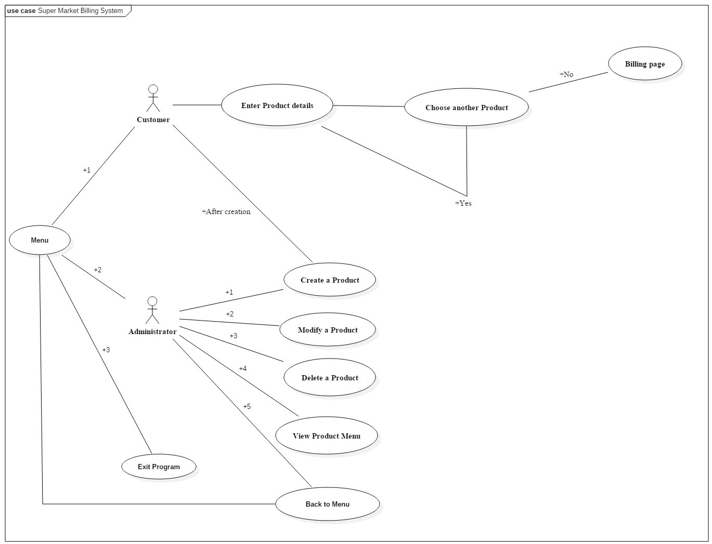

**Implementation**

The program is implemented mainly with the help of files as the database basically here used for storage of data and hence kind of limited actually.

The first option is basically for the customer. The second being the administrator and finally to exit the program itself.

The customer option would only work if the administrator has actually created a product from the administrator menu. (2).

In the 2. (Administrator option) there’s actually 5 options, wiz; Create a product, modify details of the product, delete a product, to view the product menu, Exit to the Menu.

Hence these are the functions the administrator can actually execute.

Files are usually used in the write and read modes and sometimes in the append format also. (ios::out and ios::and sometimes).

In the next header, the source code and the screen shots are given for further clearer explanation.

**Source Code**

#include<iostream>

#include<stdio.h>

#include<conio.h>

#include<process.h>

#include<fstream>

#include<string>

#include<stdlib.h>

using namespace std;

class product

{

int prno;

char name[50];

float price,qty,dis,tax;

public:

void createpr()

{

cout<<endl<<"Enter the product number"<<endl;

cin>>prno;

cout<<"Enter the product name"<<endl;

std::cin>>name;

cout<<"Enter the price of the product"<<endl;

cin>>price;

cout<<"Enter the discount percentage"<<endl;

cin>>dis;

}

void showpr()

{

cout<<"Product number: "<<prno<<endl;

cout<<"Product name: "<<std::cout<<name<<endl;

cout<<"Product price: "<<price<<endl;

cout<<"Discount percentage: "<<dis<<endl;

}

int retprno()

{

return prno;

}

float retprice()

{

return price;

}

char* retname()

{

return name;

}

int retdis()

{

return dis;

}

};

fstream fp;

product pr;

int writepr()

{

fp.open("SMBS.dat",ios::out|ios::app);

pr.createpr();

fp.write((char*)&pr,sizeof(product));

fp.close();

return 0;

}

int disp()

{

cout<<"Display all the records: "<<endl;

fp.open("SMBS.dat",ios::in|ios::out);

while(fp.read((char*)&pr,sizeof(product)))

{

pr.showpr();

}

fp.close();

return 0;

}

int dispsp()

{

int flag=0,n;

cout<<"Enter the product number: "<<endl;

cin>>n;

fp.open("SMBS.dat",ios::in|ios::out);

while(fp.read((char*)&pr,sizeof(product)))

{

if(pr.retprno()==n)

{

pr.showpr();

flag=1;

}

}

fp.close();

if(flag==0)

{

cout<<"Record does not exist"<<endl;

}

return 0;

}

int modifypr()

{

int no,found=0;

system("cls");

cout<<"Enter the product number:"<<endl;

cin>>no;

fp.open("SMBS.dat",ios::in|ios::out);

while(fp.read((char*)&pr,sizeof(product))&&found==0)

{

if(pr.retprno()==no)

{

pr.showpr();

cout<<"Enter the new details of the product:"<<endl;

pr.createpr();

int long long pos=-1*sizeof(pr);

fp.seekp(pos,ios::cur);

fp.write((char*)&pr,sizeof(product));

cout<<"The details of the product has been modified"<<endl;

found=1;

}

}

fp.close();

if(found==0)

{

cout<<"Record not found"<<endl;

}

return 0;

}

int deletepr()

{

int num;

system("cls");

cout<<"Enter the product number of the product you want to delete"<<endl;

cin>>num;

fp.open("SMBS.dat",ios::in|ios::out);

fstream fp2;

fp2.open("Temporary.dat",ios::out);

fp.seekg(0,ios::beg);

while(fp.read((char*)&pr,sizeof(product)))

{

if(pr.retprno()!=num)

{

fp2.write((char*)&pr,sizeof(product));

}

}

fp2.close();

fp.close();

remove("SMBS.dat");

rename("Temporary.dat","SMBS.dat");

cout<<"The record of the product has been deleted"<<endl;

return 0;

}

int menu()

{

system("cls");

fp.open("SMBS.dat",ios::in);

if(!fp)

{

cout<<"Error:The file cannot be opened, head over to the Admin menu to create a new file."<<endl;

exit(0);

}

else

cout<<"Product Menu:"<<endl;

cout<<"---------------------------------------------"<<endl;

cout<<"Product number:\t\tName:\t\tPrice:"<<endl;

cout<<"---------------------------------------------"<<endl;

while(fp.read((char*)&pr,sizeof(product)))

{

cout<<"\t"<<pr.retprno()<<"\t\t"<<pr.retname()<<"\t\t"<<pr.retprice()<<endl;

}

fp.close();

return 0;

}

int placeorder()

{

system("cls");

int order[50],quan[50],c=0;

float amt,damt,total=0;

char ch='Y';

menu();

cout<<"\n\n\n\n---------------------------------------------";

cout<<"\n-Place your order-"<<endl;

cout<<"---------------------------------------------"<<endl;

do

{

cout<<"Enter the product number:"<<endl;

cin>>order[c];

cout<<"Enter the quantity:"<<endl;

cin>>quan[c];

c++;

cout<<"Do want to order another product? (Y/N):"<<endl;

cin>>ch;

}while(ch=='y'||ch=='Y');

cout<<"Invoice:"<<endl;

cout<<"Product number\tProduct Name\tQuantity\tPrice\tAmount\tAmount after discount"<<endl;

for(int x=0;x<=c;x++)

{

fp.open("SMBS.dat",ios::in);

fp.read((char*)&pr,sizeof(product));

while(!fp.eof())

{

if(pr.retprno()==order[x])

{

amt=pr.retprice()*quan[x];

damt=amt-(amt*pr.retdis()/100); cout<<"\n"<<"\t"<<order[x]<<"\t"<<pr.retname()<<"\t\t"<<quan[x]<<"\t\t"<<pr.retprice()<<"\t"<<amt<<"\t\t"<<damt;

total=total+damt;

}

fp.read((char*)&pr,sizeof(product));

}

fp.close();

}

cout<<"\n\n\t\t\t\t\tTotal:"<<total;

return 0;

}

int into()

{

cout<<"-----Super Market Billing System-----"<<endl;

cout<<"\nMade by: H.Gurubalan"<<endl;

cout<<"Registration number: RA1611003010099"<<endl;

cout<<"University: SRM University"<<endl;

return 0;

}

int admin()

{

system("cls");

char ch2;

cout<<"Administration menu:"<<endl;

cout<<"1.Create a product."<<endl;

//cout<<"2.Display all products."<<endl;

//cout<<"3.Query- Display a specific product."<<endl;

cout<<"2.Modify a product"<<endl;

cout<<"3.Delete a product."<<endl;

cout<<"4.View product menu."<<endl;

cout<<"5.Back to main menu()."<<endl;

cout<<"Enter your choice:"<<endl;

ch2=getche();

switch(ch2)

{

case '1':

{

writepr();

break;

}

case '2':

{

modifypr();

break;

}

case '3':

{

deletepr();

break;

}

case '4':

{

menu();

getch();

}

case '5':

{

break;

}

default: cout<<"\a";admin();

}

return 0;

}

int main()

{

char ch;

into();

do

{

cout<<"\n\nWelcome to The Super Market Billing System Application"<<endl;

cout<<"Main Menu:"<<endl;

cout<<"1.Customer"<<endl;

cout<<"2.Administrator"<<endl;

cout<<"3.Exit"<<endl;

cout<<"Enter your choice:"<<endl;

ch=getche();

switch(ch)

{

case '1':

{

placeorder();

getch();

break;

}

case '2':

{

admin();

break;

}

case '3':

{

exit(0);

}

default:cout<<"\a";

}

system("cls");

}while(ch!=3);

return 0;

}

This is the source code of the entire project. This must be executed in Code Blocks/Dev C++. (Changes have to be made in Turbo C++).

Next is the screenshots which are given in the next page.

**Screenshots**

-This is the main menu:

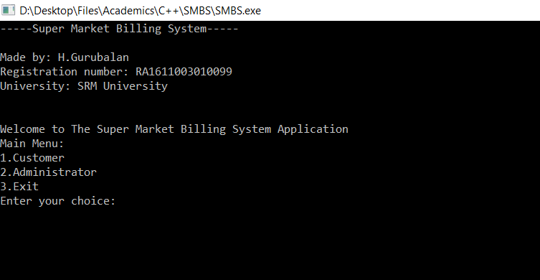

-This is the administration menu. (You should create a product first.) ( Option -2 ) 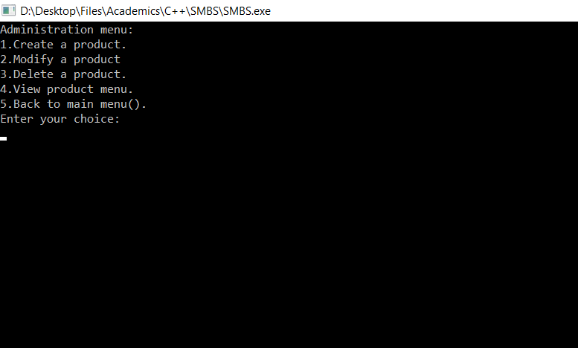

-This is creation of product. (1)

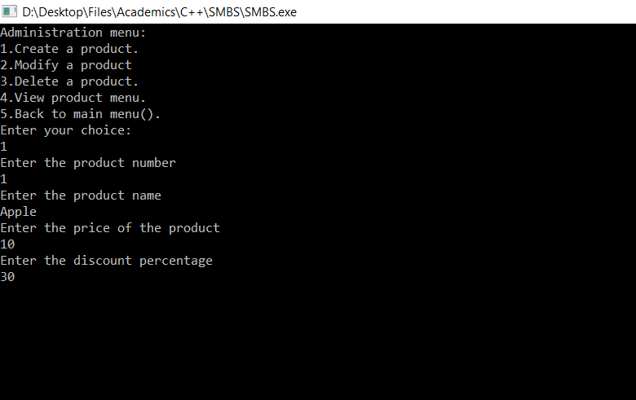

-This is to modify the details of the product. (2)

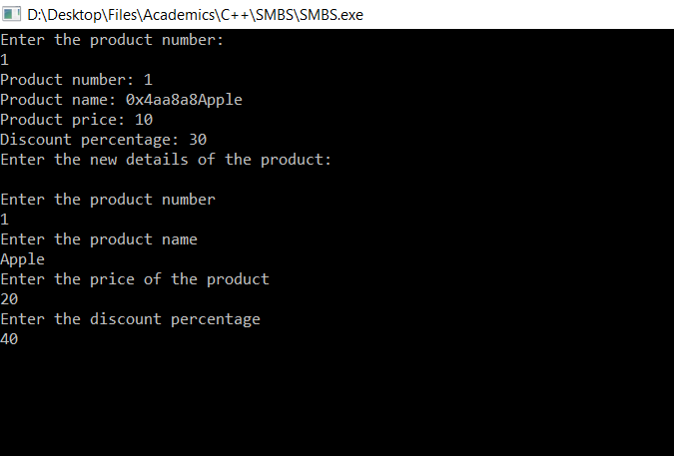

-This is to delete the product which has been created. (3)

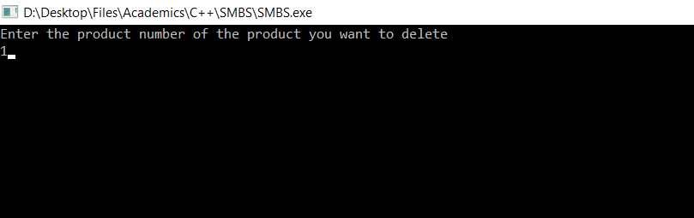

-This is the Product menu and hence displays the products created along with the details. (4)

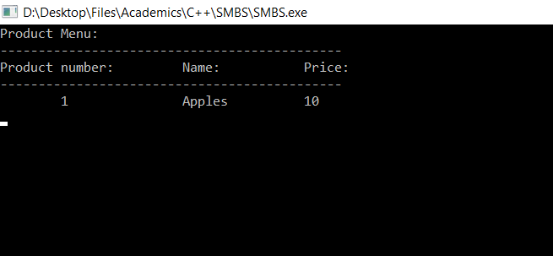

The 5th option is basically to exit back to the main menu after everything has been done. Then it is ready to be accessed by the customer/customers. Hence option (1) from the main menu is shown in the next page.

-This is the Customer page. The Product menu is also shown so that the customers can actually see and choose.

If there are more than one product created and hence is on the product menu, the customers can choose another product too. (An option is given in the program as you can see below.)

Hence, finally the amount is calculated and the discount is also included and thus the amount to be payed is displayed.

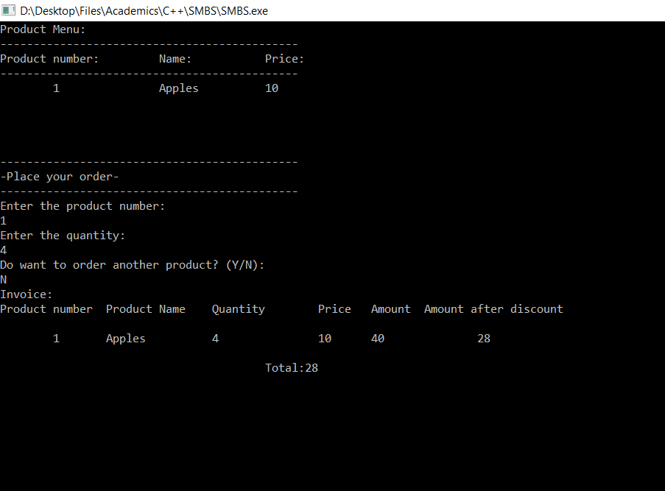

This is hence the working of the program of a simple Super market billing system using C++.